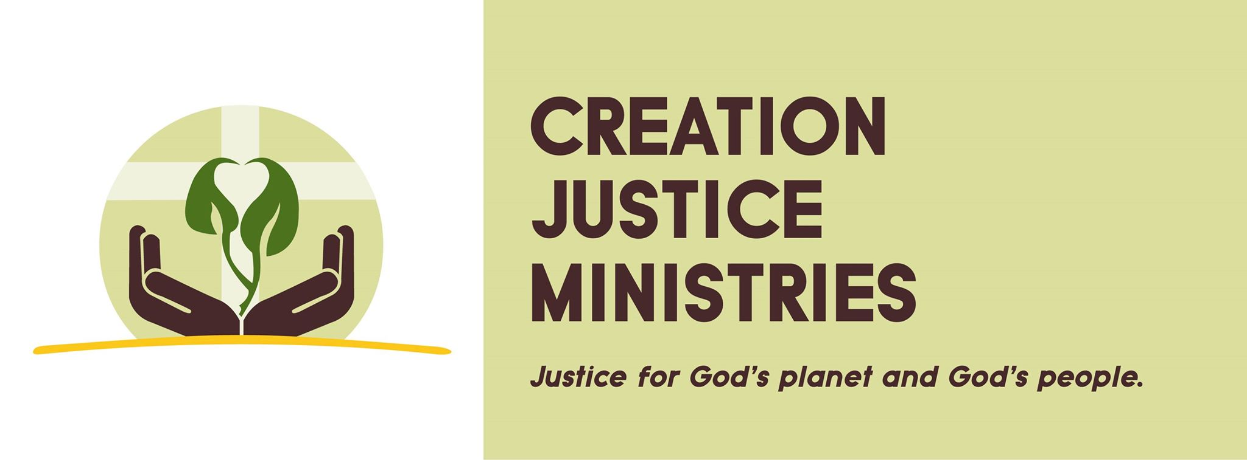
For Immediate Release
For more information please contact:
Shantha Ready Alonso (760)408-0688
Christian Faith Communities Embrace Clean Power Plan
Creation Justice Ministries Urges All 50 States to Swiftly Craft State Implementation Plans

Washington, DC - Creation Justice Ministries welcomes and celebrates the release of the Clean Power Plan.
As Christians, we are acutely aware of the threats posed by a changing climate. Already, we have seen rising floodwaters, severe droughts, disrupted access to food, harsh storms, higher rates of asthma, and increased vector-borne diseases. Climate change is most harming the vulnerable among us: people living in poverty, older adults, and people living in countries least responsible for contributing to climate change.
Our faith communities are on the front lines of providing relief and aid to those who are bearing the unequal burden of climate change. Now, with the Clean Power Plan, we have a chance to prevent suffering by limiting a major contributor to climate change: carbon pollution.
We urge every state to create a strong and effective state implementation plan that successfully meets carbon reduction targets --- without shifting costs to impoverished communities. In particular, we encourage renewable energy projects to meet state carbon reduction goals and to generate new jobs for working families. The Clean Power Plan allows each state to develop its own state implementation plan to meet a customized carbon reduction target. It elegantly recognizes the diversity of energy landscapes in the United States, giving each state an opportunity to account for the local economy as well as local eco-systems.
God’s creation is sacred, and we are called to responsibly steward the gifts of creation while protecting our vulnerable neighbors. Adopting the Clean Power Plan in every state will help us live out our faith commitments to stewardship and justice.

Creation Justice Ministries represents the creation care and environmental justice policies of major Christian denominations throughout the United States. We work in cooperation with 38 national faith bodies, including mainline Protestant, Black Church, Peace Church, and Orthodox communions.

