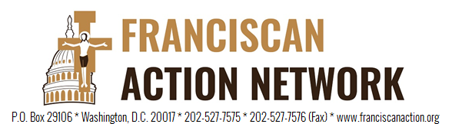

Immediate Release
August 3, 2018
Media Contact: Janine Walsh
(203) 685-1856
walsh@franciscanaction.org

Franciscans Argue Proposal to Roll Back Vehicle Emissions Standards is Major Step Backwards

Washington DC - On Thursday, the Trump Administration announced a proposal to freeze fuel-efficiency requirements, justifying the move with claims that the move will result in huge economic savings. The Franciscan Action Network (FAN) vehemently disagrees with these claims and feel the proposal is a major step backwards for the environment, public health, and the economy.

Research shows freezing CAFE standards is highly problematic on several levels. Easing the Obama-era standards would increase U.S. fuel consumption by roughly half a million barrels of oil per day, and would lead to an increase in greenhouse-gas emissions. This will mean families will have to pay more for gasoline for their cars and air quality will go down. The transportation sector, which has emerged as the nation’s largest source of carbon dioxide emissions, must instead aspire to the highest possible fuel efficiency standards to help diminish greenhouse-gas emissions and to continue to be competitive in the international market.

A large part of Franciscan charism is to care for all of God’s beautiful creation. Thirteenth century Franciscan theologian, St Bonaventure tells us that how we choose and what we choose makes a difference – first in what we become by our choices and second what the world becomes by our choices. As people of faith, it is our moral responsibility to ensure we leave a clean, livable planet for generations to come.

“We are living in a world that is getting hotter. We see the wildfires in the west and are creating another dust bowl in the Midwest,” said FAN executive director, Patrick Carolan. “We always need to be choosing a path that reduces our carbon footprint, protects the environment, and cares for all of God’s wondrous creation. Not a path that destroys it.”

###

