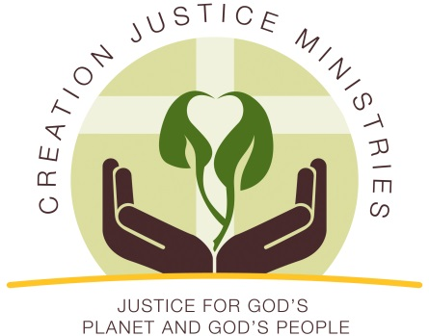
Christian Leaders Welcome Opportunity to Cut Methane Waste and Protect Community Health

January 22, 2016
Contact: Shantha Ready Alonso
760-408-0688
Shantha@creationjustice.org

The Bureau of Land Management announced a proposed standard to reduce methane waste by oil and gas industries that operate on taxpayer-owned public lands. Reducing methane waste and pollution is a matter of faith. Hear perspectives from Wyoming, New Mexico, Colorado, and Utah about the new proposal.

“In Wyoming, we welcome this opportunity for public dialogue about stewardship of God’s creation, including the finite natural resource of natural gas. Right now, enough natural gas is being wasted annually on America’s public lands to supply the entire state of Wyoming for a year.”
Rev. Chesie Lee, Executive Director, Wyoming Association of Churches
Cheyenne, WY

"God hallowed human life by entering it fully as a child born in Bethlehem. As people of faith, we are obligated to care for one another and the places in which we live because they are sacred. We welcome the new proposed standards for methane emissions being proposed by the Bureau of Land Management as an opportunity to be better stewards of our natural resources and to care for those whose health is threatened by excessive methane emissions."
Rev. Dr. Donna McNiel, Executive Director, New Mexico Conference of Churches
Albuquerque, NM

“God’s creation is entrusted for us to steward carefully to ensure it will be there for future generations. Oil and gas companies operating on federal and tribal lands are wasting more than $330 million worth of natural gas each year through leaks and the wasteful practice of venting and flaring. This practice deserves public examination, and I welcome the opportunity for dialogue about how we can do better.”
Adrian Miller, Executive Director, Colorado Council of Churches
Denver, CO

“As Lutheran Christians, we believe that God wants us all to have abundant life, free of sickness and safe from harm’s way. Solutions that would stop natural gas venting, flaring, and leaking can cut ozone-forming pollutants and toxic chemicals such as benzene that post a severe threat to the health and safety of western communities. Therefore, I welcome the beginning of the comment period as an opportunity to have important public dialogue about matters of life – health and safety.”
Rev. David Nichols, Mount Tabor Lutheran Church
Salt Lake City, UT

"Latter Day Saints (LDS) people believe that we should not only protect the health and wellbeing of those who might be affected by the air pollution caused by mining activities, but also that we have a divine calling to care for the earth and preserve it for future generations. Mormon Environmental Stewardship Alliance (MESA) speaks on behalf of the thousands of LDS faithful from Utah and beyond, and we welcome a robust public dialogue about methane emission reduction on Bureau of Land Management land."
Ty Markham, Chair, Mormon Environmental Stewardship Alliance
Torrey, UT

